Recommendations |  | Additional Resources
"Encourage daily, high-quality physical education for students from kindergarten through 12th grade. The goal should be 150 minutes per week for elementary schools and 225 minutes per week for secondary schools." (http://www.letsmove.gov/)  Diamond Conceptual Framework: A K-12 Road Map for Physical Education  Students should first learn the fundamental skills needed to be successful in physical activities.  Next they should experience a variety of activities with the goal of finding a few they enjoy.  Lastly, we want them to become proficient in a few chosen activities with the hope that they will continue to participate in them throughout their lives.  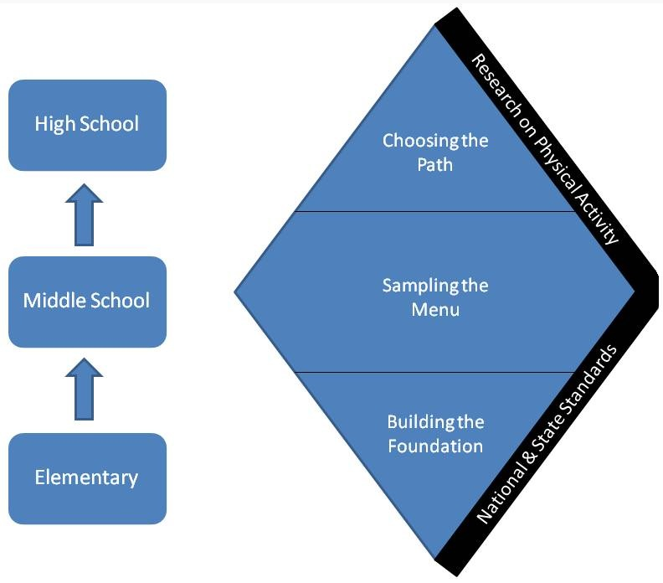 |  | - http://www.supportrealteachers.org/no-excuses-a-film-about-qpe1.html  - http://activelivingresearch.org/  - http://www.cdc.gov/HealthyYouth/physicalactivity/guidelines.htm  - http://www.phitamerica.org/Benefits_of_P_E__in_School.htm  - http://www.shapeamerica.org/advocacy/resources/toolkit/  - http://www.congressweb.com/shapeamerica
 |  | How You Can Help |  | Promoting quality physical education through accountability and free access to information and resources
 |  | - Watch our documentary No Excuses (http://www.supportrealteachers.org/no-excuses-a-film-about-qpe1.html) and educate others about the importance of physical education.  - Become involved in your local community physical education programs.  - Support physical educators and their programs.  - Support legislation that supports physical education requirements and programs: http://www.congressweb.com/shapeamerica.  - For more ways to help: http://www.supportrealteachers.org/how-to-advocate-for-your-program.html. |  | We have sections dedicated to:  - No Excuses! A film about Quality Physical Education (our free documentary)  - Advocacy pieces on the importance of quality physical education  - Effective teaching strategies that can be used by veteran and new teachers  - Teacher resources, ranging from lesson planning tools to information on professional development to technology that can be used by teachers  - Fitness resources that provide information and tools related to fitness

What are the Benefits of Physical Education |  | What does Quality Physical Education Include? |  | What Organizations say about Physical Education
Preparing students to be physically active for a Lifetime  - Improves physical fitness  - Improves motor skill development  - Improves academics  - Teaches self-discipline, social skills, and personal responsibility  - Strengthens peer relationships  - Provides physical activity  - Reduces stress  - Improves self-confidence and self-esteem  - Provides experience with goal setting  “Eliminate physical education to increase time for reading and math, the theory goes, and achievement will rise. But the evidence says otherwise.” (Why We Should not Cut P.E., Educational Leadership)  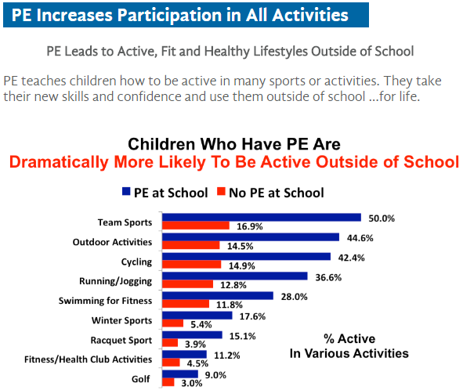  (http://www.phitamerica.org/Benefits_of_P_E__in_School.htm) |  | Find your state standards that provide more specific learning outcomes for each grade level:  http://www.shapeamerica.org/standards/pe/statestandards.cfm  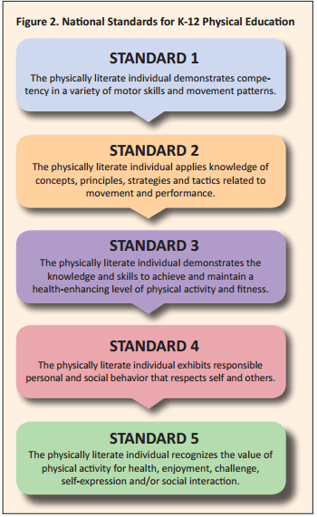  (http://www.shapeamerica.org/upload/TheEssentialComponentsOfPhysicalEducation.pdf) |  | "Quality, daily physical education in the nation’s schools is an important part of a student’s comprehensive, well-rounded education program and a means of positively impacting life-long health and well-being." (American Heart Association and American Stroke Association)  "Every human being has a fundamental right of access to physical education and sport, which are essential for the full development of his personality." (United Nations Educational Scientific and Cultural Organization)  “The U.S. Department of Health and Human Services recently released national health objectives for 2020 with recommendations that underscore the importance of physical activity in schools, including daily physical education, regular recess, and access to physical play and exercise spaces during non-school hours and in the summer.” (Active Living Research)  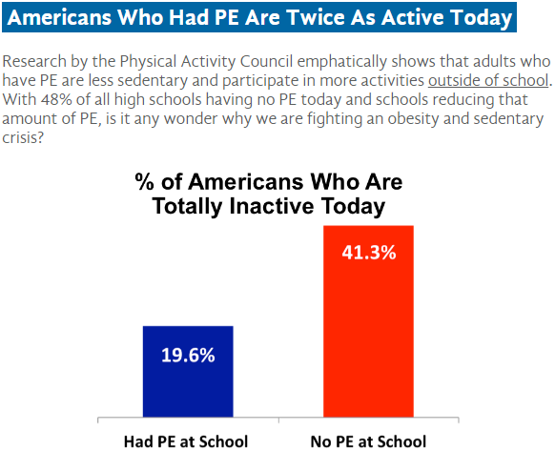  (http://www.phitamerica.org/Benefits_of_P_E__in_School.htm)

