Name: |  | Name:

- Remember to breathe, keep your back straight (for most exercises), and DO NOT lock out your joints.
- In groups of two, have each partner the following:
______________________________________________________________________________
- Find an available bar and practice each of the grips. Do not add any weight to the bar.
- Pronated  - Supinated  - Alternated  - Hook (same as pronated except thumb is under the index and middle finger)  - Common  - Narrow  - Wide | 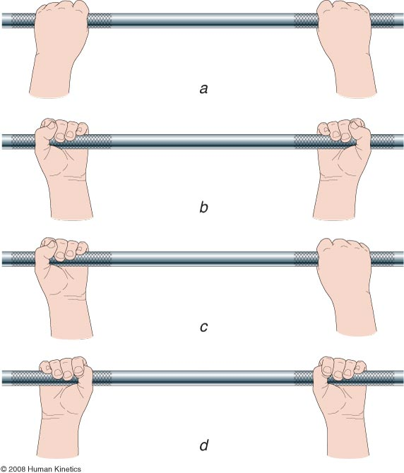
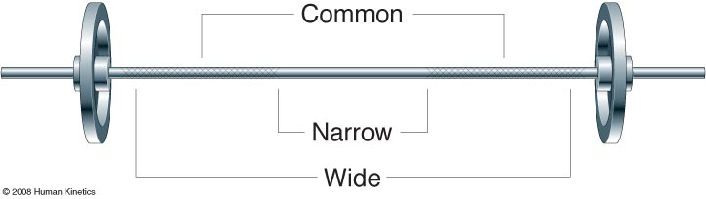
______________________________________________________________________________
- Use the seated back row with little to no weight and practice proper breathing technique.
- Use the seated back row with little to no weight and practice the Valsalva maneuver.

- Exhale during lift  - Inhale during return  - Contract abdomen but do not breathe out  - Keep your back straight | 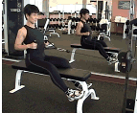

- Pick a Nautilus machine and make the necessary adjustments (weight machines)

- The joint that is the axis of rotation for exercise should line up with the red dot on weight machines.  - Benefit of weight machines: Focuses on primary muscles and is safer.  - Cons of weight machines: Doesn't involve stabilizer muscles as much (less holistic)  - Other types of machines (gas, liquid) | 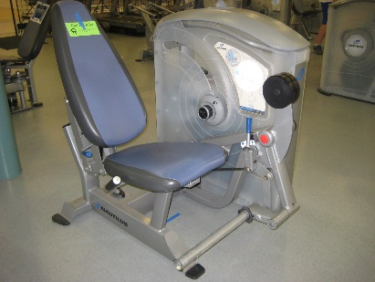

______________________________________________________________________________
- Find an available bar to lift off the ground and practice the proper technique. Add 5 pounds to the bar and use the collars to secure the weight.
- Use your legs for power  - Keep your weight over your heels  - Keep the bar close to your body and your back straight  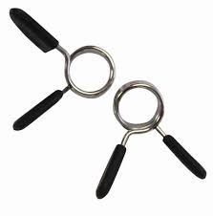 | 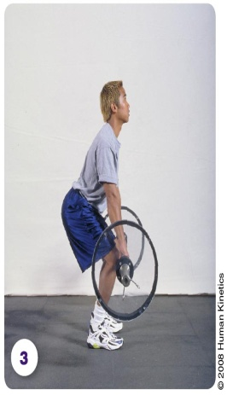 | 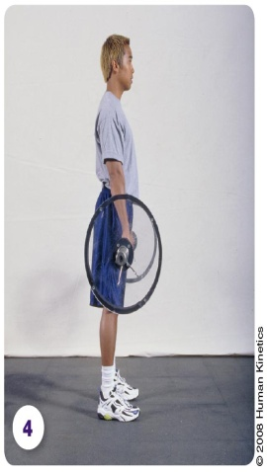
______________________________________________________________________________
- Find an available bench and practice the 5 point body contact and proper spotting techniques. Do not add weight to the bar.
- Head is placed firmly on the bench or back pad.  - Shoulders and upper back are placed firmly and evenly on the bench or back pad.  - Buttocks are placed evenly on the bench or seat.  - Right and left feet are flat on the floor. | - Communicate when to liftoff, when to help, and approx. # of reps.  - Use an alternated grip that is narrower than the lifters.
______________________________________________________________________________
- Find an available seat and practice the 5 point body contact and proper spotting technique. Use 5 pound dumbbells and perform shoulder presses
- Head is placed firmly on the bench or back pad.  - Shoulders and upper back are placed firmly and evenly on the bench or back pad.  - Buttocks are placed evenly on the bench or seat.  - Right and left feet are flat on the floor.  - Communicate when to liftoff, when to help, and approx. # of reps.  - Spot nearest the weight (wrists). | 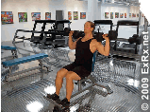

- Observe preacher equipment. They are used to isolate specific muscles (similar to weight machine). | 


